COMPILATION OF VIEWS AND INFORMATION TO DATE – 25th September 2021
JANET - TisPlan v Intelligent Land proposals

TisPlan Policy No | What does TisPlan say? | What is IL proposing? | Comments
HNA.1 Natural Assets and Biodiversity | new development should respect landscape, improve biodiversity & natural assets. Exclude areas at high risk from flooding.  Appropriately mitigate adverse impact | retain the wooded embankment at the entrance to the site; adding an attenuation pond which might attract wildlife. Line of tree planting along the line of the railway; trees along the road by the care home | pond is a saftety hazard; insufficient attention to conserving and enhancing landscape and biodiversity. No provisions for tree planting along the roads.  Insufficient regard for impact on the River Avon SAC and impact of development on the River Nadder
HNA.2  Conservation Areas | identify and appropriately address impacts on the rest of the village | IL acknowledge relevance of Policy HNA.2 to the Station Works site | IL state that the Station Works site is not easily visible from the centre of Tisbury, (which is in the valley). They are being economical with the truth – the site is highly visible from the higher ground all around the village.
HNA.3 Water in the envt | new development to be built to optimum water efficiency  standards |  | will probably say these are reserved matters
The proposal is for a mixed housing development | moderate development; sympathetic design to blend with the existing settlement; respect constraints and aspirations of the AONB; broad mix of housing |  | the design and layout is hardly sympathetic to the character of the AONB – it's unimaginative and makes no attempt to blend into the landscape.It's just a housing estate like any other, plonked into the site
BL.1 Housing Mix | mix of housing types; affordable low‐cost; suitable accommodation for ageing population; CLT encouraged | proposals are for a mix of houses and flats, including small units suitable for starter homes or elderly wanting to downsize. | no mention of how many units are genuine affordables; too many units ‐ 50% over the max proposed in TisPlan; Care Home not discussed with CCG

BL.2 Affordable  Housing | Affordable housing allocation  policy |  | needs negotiation of a S106 Agreement
BL.3 Brownfield Development | permit allocation and appropriate development of brownfield sites according to size and location; no adverse impact on the AONB; no unacceptable impact on the road network; no adverse impact on amenity and living conditions of other  residents
BL.4 Design & Landscape | positive plans for high quality design; conserve and enhance the landscape & scenic beauty; demonstrate regard for SDC Landscape Character Assessment
BL.5 Energy | Energy efficient standards but without compromising AONB; low level lighting; electric vehicle  infrastructure |  | probably reserved matters
BL.6 Infrastructure | Sympathetic siting of infrastructure to avoid adverse  impact on the AONB |  | probably reserved matters
BL.7 Station
Works allocation
TR.1 Parking
provision

TR.2 Railway Station | improvements to the railway service and infrastructure; extend parking ; conserve the  character
TR.3 Traffic impact and road safety | Developments that will generate significant levels of additional traffic should include within their Transport Statement consideration of how traffic impacts will be mitigated to ensure that the rural character of the CCWWD AONB and its villages and hamlets will be conserved. |  | road straight through the middle of the site will encourage speeding, and especially if the 2nd line is opened, traffic will race through to get to the station. Lack of new parking provision will mean commuters park along the roadside and in the housing car parks.
TR.4 Sustainable transport | provision of footpaths and cycle routes; provision of infrastructure for sustainable transport; improved access for all  users |  | this should include provision of a safe crossing for the railway
EB.1 Employment & Business | To promote business provision and encourage new employment opportunities appropriate to the needs and skills base of the community. | existing employment/business units will be removed and replaced with 70 bed care home | insufficient evidence provided that a care home would be appropriate; no consideration for the relocation of existing businesses; no provision of small business units as envisioned by the discussion in TisPlan – "Any proposals for changes  of use at Station Works should include consultation with the local business community to determine how  best to meet their business needs."

LCW.1 Local Green Spaces | To provide quality open, natural or leisure spaces as an integral part of new development. | Public open space seems to be provided at the top of the embankment; attenuation pond at  the eastern end of the site | unlikely that anyone will be all that keen to climb to the top of the embankment when it doesn't lead anywhere. There is no footpath into the open countryside. Will  encourage trespassing.
LCW.2 Community buildings |  | no mention
LCW.3 Amenity
spaces

Clerk - Environment Agency: Red = High Risk
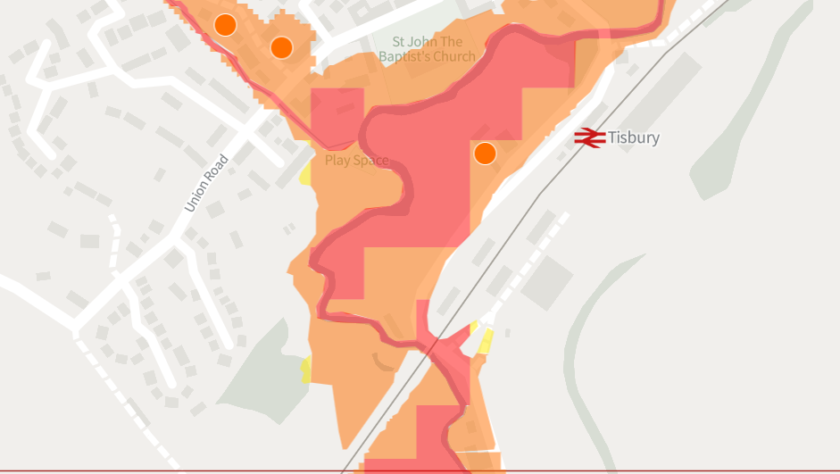
Any planning applications involving land at risk of flooding is automatically considered by the Environment Agency as a statutory consultee.
A quote - I am a bit confused as to why they want to put the pedestrian( vehicle?) access through the middle arch. Obviously the Nadder flows through the western most one, but as the proposed pedestrian access to the site emerges almost into the eastern arch, it would appear to make more sense to have this as the pedestrian route (although the middle arch has 150mm less headroom). Hopefully the traffic lights would have a foot crossing sequence.
I see that there is a pedestrian level crossing at the northern edge of the site – streetview below. Unless this is closed off, I would imagine that this would be used by most people to access the High Street, which could be quite high risk. A foot bridge here would get around the issues at the other end of the site, and may not cost any more than the traffic lights and proposed raised footpath / cycleway. Just a thought! Of course they could try and squeeze a footpath through the river arch, but I think we may struggle with that.
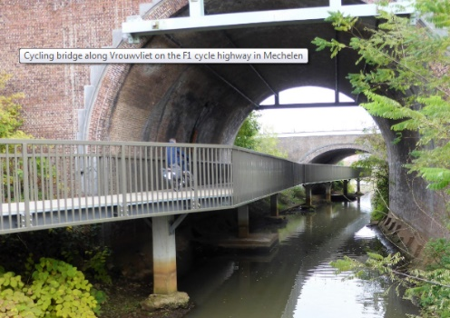

Plus input from Operational Flood Working Group (OFWG) – WC and EA Officers:
It is entirely up to TCHs to propose any mitigation measures necessary. If it is not suitable WC Officers will advise Planning not to allow the scheme to progress.
We should gather as many photographs and data on frequency as we can.
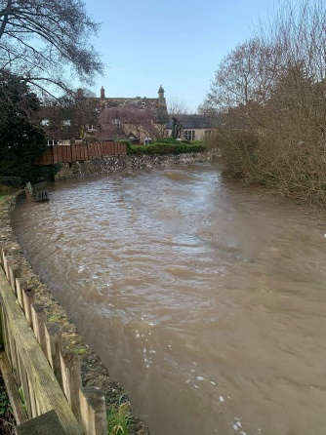
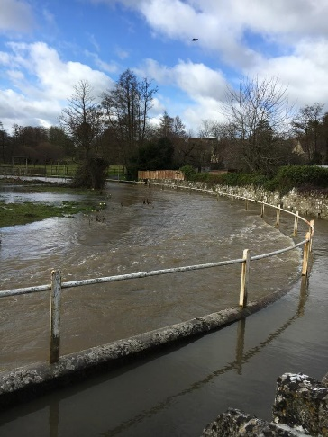
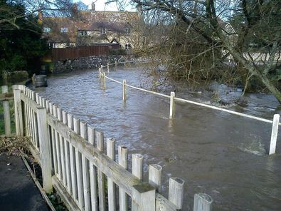
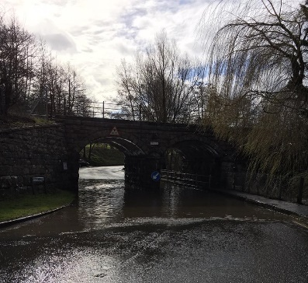
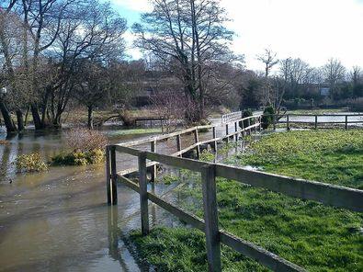
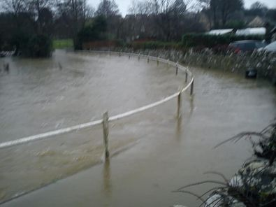
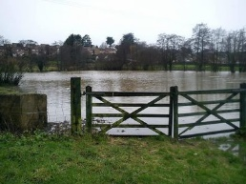
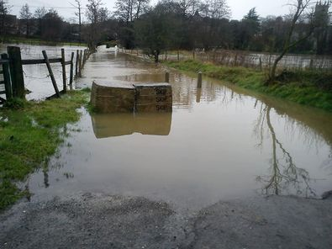..
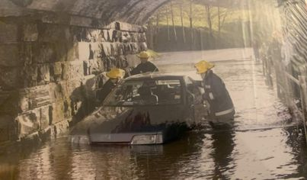

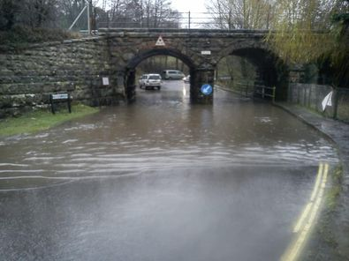
Rosie - Potential Impact on Nadder River from Strategic Environmental Assessment for the Tisbury and West Tisbury Neighbourhood Plan
My understanding is that this impact assessment was based on a number given of 60 dwellings, with
a consistent reference to the importance of ‘scale and scope’ (NTS3) of the proposal of the
Neighbourhood Plan. This would mean that if the number is increased, as proposed by Intelligent
Land, there is likely to be a significantly higher impact on the Nadder River. Throughout the report
there is reference to ‘scale and scope’ being significant to any environmental impact.
It also assumes a mixture of housing and employment. In terms of people being resident and having
a potential impact on the environment, the care home should be more accurately considered
residential rather than employment, which would bring the total of units above 100, a number
quoted as being of significance for the whole of Tisbury, in terms of its potential effects on the
Nadder River: the rare species present in and around its shores downstream of the proposed
development, as well as the existing population of native brown trout. P21 ‘In terms of the key
allocation proposed through the Neighbourhood Plan at Station Works, the site is within an Impact
Risk Zone for the River Avon SSSI relating to residential developments of over 100 dwellings’. P4
refers to the need to ‘provide for modest growth’ with the need for employment and housing to be
balanced. Being in AONB ‘a modest and sustainable level of development’ is required.
There is also consistent reference to the need for any proposed development or plan to state how
they will take active steps to enhance the water quality, as well as protecting species, environments
and habitats that support biodiversity. There does not appear at this stage to be any steps being
suggested that would support the continued improvement of the Nadder River
. P11 Will the option/proposal help to:
• Ensure that no development takes place in areas at higher risk of flooding, taking into the likely
effects of climate change into account?
• Improve green infrastructure networks in the plan area to support adaptation to the potential
effects of climate change?
• Sustainably manage water run-off, ensuring that the risk of flooding is not increased (either within
the plan area or downstream) and where possible reduce flood risk?
• Ensure the potential risks associated with climate change are considered through new
development in the plan area?
• Increase the resilience of biodiversity in the plan area to the effects of climate change?
Any consideration on the impact would have to take into account immediate effects on the river,
not only in Tisbury but further downstream, as well as any potential impact on the water meadow
within Tisbury. P30 The citation for the SSSI states: ‘The River Avon and its tributaries are of national
and international importance for their wildlife communities. The Wiltshire tributaries, of interest in
their own right and with contrasting geologies, are included primarily on account of their
importance, with the Avon itself, for internationally rare or threatened species (Ranunculus
vegetation, sea lamprey, brook lamprey, bullhead, Atlantic salmon and Desmoulin’s whorl snail)

There would also need to be detailed proposals of mitigation of potential impacts from climate
change, with predictions of the increased risk of flooding in the vicinity of the proposed
development in view of its proximity to the Nadder River. P11 ‘Fluvial flooding linked to the River
Nadder is a major risk in the Neighbourhood Area’
P44 Water Framework Directive:
• Enhance the status and prevent the further deterioration of aquatic ecosystems and
associated wetlands which depend on aquatic ecosystems;
• Promote the sustainable use of water;
• Reduce the pollution of water, especially by ‘priority’ and ‘priority hazardous’ substances; and
• Ensure the progressive reduction of groundwater pollution.
P46 In terms of water quality, the requirements of the Water Framework Directive are likely to
lead to continued improvements to water quality in watercourses in the wider area. Water
quality is also likely to continue to be affected by pollution incidents in the area, the presence of
non-native species and physical modifications to water bodies. Water availability in the wider
area may be affected by regional increases in population and an increased occurrence of
drought exacerbated by the effects of climate change.
These concerns need to be particularly addressed in terms of the access proposed via the
railway bridge, which already has periods of diminished access due to flooding. This is of
particular relevance to this site which would be situated beyond the southern boundary of the
village as delineated by the river and railway line. P42 ‘ Area 9, ‘Station’ gateway and floodplain:
The special interest of this sub area is based on the railway and the river, which form a strong
southern boundary to the village.’
Any development would need to highlight how they propose to reduce resource use and what
significant positive effects the development would make to the waterways and tributaries with
specific examples of biodiversity offsetting P15 ‘ All allocations have the potential to have impacts on
biodiversity assets if located inappropriately and have poor design and layout. Likewise all allocations
have the potential to promote net gains in biodiversity value. In this context, for all sites, potential
effects on biodiversity depend on elements such as the provision of green infrastructure to
accompany new development areas and the retention and incorporation of biodiversity features.’

The Natural Environment White Paper (NEWP)12 sets out the importance of a healthy, functioning
natural environment to sustained economic growth, prospering communities and personal well-
being. More evidence would need to be provided of how this development would be able to achieve
this, particularly given the increased proposed number of units for residents and would need to
clearly demonstrate how the development would. ‘limit impacts on the AONB from the Station
Works site through sensitive development.’

Relevant sections from the SEA

NTS3 ‘In relation to the ‘biodiversity’ sustainability theme, the scope and scale of the proposed
policy approaches relating to the natural environment will help ensure that wide ranging benefits in
relation to this theme are secured through the Neighbourhood Plan, and appropriate protection
provided to key internationally and nationally designated biodiversity sites in the area.’
‘The current version of the TisPlan will initiate a number of beneficial approaches regarding the
‘transportation’, ‘land, soil and water resources’ and ‘climate change’ sustainability themes.
However these are not considered to be significant in the context of the SEA process given the scope
of the Neighbourhood Plan and the scale of proposals
P4: talks of the need to ‘provide for modest growth’ with the need for employment and housing to
be balanced. Being in AONB ‘a modest and sustainable level of development’.
P7 talks of SSSI I Impact Risk Zone for the River Avon ‘waterway should be protected from the
impacts of future developments and where possible enhanced’
P8 cites key habitats and species present
‘Fluvial flooding linked to the River Nadder is a major risk in the Neighbourhood Area’
‘TisPlan should seek to increase the Neighbourhood Area’s resilience to the effects of climate change
through supporting adaptation to the risks associated with climate change in the area.’
P10 ‘Will the option/proposal help to:
• Support continued improvements to the status of the River Avon SAC / River Avon System SSSI?’

P11 Will the option/proposal help to:
• Ensure that no development takes place in areas at higher risk of flooding, taking into the likely
effects of climate change into account?
• Improve green infrastructure networks in the plan area to support adaptation to the potential
effects of climate change?
• Sustainably manage water run-off, ensuring that the risk of flooding is not increased (either within
the plan area or downstream) and where possible reduce flood risk?
• Ensure the potential risks associated with climate change are considered through new
development in the plan area?
• Increase the resilience of biodiversity in the plan area to the effects of climate change?
Will the option/proposal help to:
• Support improvements to water quality?
P 15 All allocations have the potential to have impacts on biodiversity assets if located
inappropriately and have poor design and layout. Likewise all allocations have the potential to

promote net gains in biodiversity value. In this context, for all sites, potential effects on biodiversity
depend on elements such as the provision of green infrastructure to accompany new development
areas and the retention and incorporation of biodiversity features.
the redevelopment of brownfield land increases scope for direct improvements to climate change
resilience.
P16 In terms of water quality, it is difficult to come to a conclusion regarding the potential for
development at any given location to result in negative effects without an understanding of the
design measures that will be put in place. For example sustainable drainage systems – SuDS – are an
effective means of minimising surface water runoff and hence pollution. However, given the
potential for development on previously developed land to reduce land contamination, Option 2 has
the potential to lead to medium and long term improvements to water quality.
P21 In terms of the key allocation proposed through the Neighbourhood Plan at Station Works, the
site is within an Impact Risk Zone for the River Avon SSSI relating to residential developments of over
100 dwellings. Whilst it is uncertain whether or not this level of housing will be delivered on the site,
BL.7 (Site Allocation: Station Works) sets out provisions for protecting the wildlife interest of the site,
with the policies discussed above also helping to limit potential effects on the condition of the SSSI
(and contributing to potential enhancements). Similarly, whilst the underutilised nature of parts of
the site provides potential for protected species to be present, the policies discussed above will
support ecological networks in the area, with benefits for protected species present locally. ??
Policy HNA.1 (Natural Assets and Biodiversity) also provides additional provisions relating to the
River Nadder and Chilmark SACs. This includes through seeking to ensure that the water meadows
adjacent to the River Nadder are protected from any future development, and that an impact
assessment will be required to identify any potential risks to SAC bat species where development
may lead to the loss or modification of buildings used for roosting, disruption to their flight routes,
or through the removal of vegetation and the installation of new lighting.
Overall therefore, the TisPlan policies offer a proactive approach to protecting and enhancing
habitats and species and ecological networks in the Neighbourhood Plan area, as well as the
integrity of the key designated biodiversity sites in the area.
limit impacts on the AONB from the Station Works site through sensitive development.
P24 Policy HNA.1 (Natural Assets and Biodiversity), which supports green infrastructure
enhancements, and Policies LCW.1 (Local Green Spaces) and BL.6 (Infrastructure Provision), which
support the provision of new and improved green space, will enhance the quality of land and water
resources through promoting the ability of natural processes to support soil and water quality. This
will be further supported by BL.4 (Design and Landscape) which requires development proposals to
be of designs that are sympathetic to the landscape and its setting.
P24 The draft plan puts forward the Station Works site for mixed use development. Due the size of
the site, it is anticipated that allocation of this site will meet the Neighbourhood Plan area’s
employment and residential needs.

P30 The citation for the SSSI states: ‘The River Avon and its tributaries are of national and
international importance for their wildlife communities.
The Wiltshire tributaries, of interest in their own right and with contrasting geologies, are included
primarily on account of their importance, with the Avon itself, for internationally rare or threatened
species (Ranunculus vegetation, sea lamprey, brook lamprey, bullhead, Atlantic salmon and
Desmoulin’s whorl snail)
According to a site condition assessment of the SSSI undertaken by Natural England in April 2009,
the SSSI unit within the Neighbourhood Area (Upper Nadder) is ‘Unfavourable- No change’ due
water pollution and invasive species.14
P31 Tisbury village is within the SSSI Impact Risk Zone for the River Avon SSSI, for ‘residential
development of 100 units or more’.
As such, similar development taken forward through the Neighbourhood Plan may have the
potential for effects on these SSSIs without appropriate avoidance and mitigation measures.
Small areas of Purple Moor Grass and Rush Pastures BAP Priority Habitat and Lowland Fens BAP
Priority Habitat located adjacent to the River Nadder west of Place Farm;
P34 Climate change risk assessment 2012:
The evidence report contains six priority risk areas requiring additional action in the next five years:
1. Flooding and coastal change risks to communities, businesses and infrastructure;
4. Risks to natural capital, including terrestrial, coastal, marine and freshwater ecosystems, soils
and biodiversity;
P35 Direct development away from areas highest at risk of flooding, with development ‘not to
be allocated if there are reasonably available sites appropriate for the proposed development in
areas with a lower probability of flooding’. Where development is necessary, it should be made
safe without increasing levels of flood risk elsewhere. • Take account of the effects of climate
change in the long term, taking into account a range of factors including flooding. Adopt
proactive strategies to adaptation and manage risks through adaptation measures including well
planned green infrastructure. The Flood and Water Management Act25 highlights that
alternatives to traditional engineering approaches to flood risk management include: •
Incorporating greater resilience measures into the design of new buildings, and retro-fitting
properties at risk (including historic buildings); • Utilising the environment in order to reduce
flooding, for example through the management of land to reduce runoff and through harnessing
the ability of wetlands to store water; • Identifying areas suitable for inundation and water
storage to reduce the risk of flooding elsewhere;
• Creating sustainable drainage systems (SuDS)26 Further guidance is provided in the document
‘Planning for SuDs’. 27 This report calls for greater recognition of the multiple benefits that
water management can present. It suggests that successful SuDS are capable of ‘contributing to
local quality of life and green infrastructure’.
P42 Area 9, ‘Station’ gateway and floodplain: The special interest of this sub area is based on
the railway and the river, which form a strong southern boundary to the village.
P44 Water Framework Directive:

• Enhance the status and prevent the further deterioration of aquatic ecosystems and
associated wetlands which depend on aquatic ecosystems; • Promote the sustainable use of
water;
• Reduce the pollution of water, especially by ‘priority’ and ‘priority hazardous’ substances; and
• Ensure the progressive reduction of groundwater pollution.
P46 In terms of water quality, the requirements of the Water Framework Directive are likely to
lead to continued improvements to water quality in watercourses in the wider area. Water
quality is also likely to continue to be affected by pollution incidents in the area, the presence of
non-native species and physical modifications to water bodies. Water availability in the wider
area may be affected by regional increases in population and an increased occurrence of
drought exacerbated by the effects of climate change.

Julie - Report on the Contamination of land at Station Works

1. Introduction: The purpose of this report is summarise various reports in relation to the contamination of land at Station Works and the context surrounding development of the site.

2. Tisbury and West Tisbury Neighbourhood Plan
The vision outlined for Housing and buildings (Section 3) identifies that “Within the plan area there are development opportunities both small and moderate in size, which can
contribute to housing development targets set by Wiltshire Council and address
the range of housing needs in the area” and that “The redevelopment of available and suitable brownfield sites will meet local housing and employment needs over the plan period.”

2.1 The Basic Conditions Statement submitted with the Plan illustrates the
ways in which the Plan Policies both individually and in combination address the
requirements for sustainable development with its three aspects:
Economic - contributing to building a strong economy: ensuring that sufficient land is available in the right place and at the right time.
Social - providing homes that will meet the needs of future generations, and supporting the community’s health, social and cultural well-being.
Environmental - protecting our environment: using natural resources prudently, minimising waste and pollution, and mitigating climate change.
In this context, contamination can be seen as a form of pollution should the site be developed for residential purposes: Contamination is simply the presence of a substance where it should not be or at concentrations above background. Pollution is contamination that results in or can result in adverse biological effects to resident communities.

2.2 Tisplan identifies that any potential development at station works “may present a risk to the features of the River Avon SAC due to potential contamination and the site’s close
proximity to the river, despite it lying some 2 kilometres upstream from the
SAC.”

2.3 Tisplan also identifies that any new development may lead to increased phosphate discharges from sewage treatment works or package treatment plants. Such increases may exceed the government’s target for phosphate levels in the River Nadder. The main sources of phosphate pollution in rivers and lakes come from:
“Sewage effluent (primarily from water industry sewage treatment works) and losses from agricultural land. Food waste, food and drink additives and P dosing of drinking waters all contribute to sewage P loadings. Septic tanks and package sewage treatment plants are small sources nationally but can be important sources locally, particularly in the headwaters of catchments. Leaking water mains are a newly identified P source. entering ground and surface waters”

All new development permitted between 2018 and 2025 must be ‘phosphate neutral’ and this will be achieved by delivering the measures contained in the Interim Development Plan (IDP) agreed by the River Avon SAC Working Group. This requires higher optional water efficiency standards provided for by the building regulations which are currently a maximum water use of 110 litres per person per day (G2 of the Building Regulations 2010). Additional mitigation measures will be funded through CIL payments. In exceptional circumstances, it may be necessary for developers to provide for further measures beyond those funded by CIL.

2.4 The Policy BL.3 “Building on Brownfield Sites” indicates that the Parish Council should support the development of these sites subject to 3 conditions.
1. The character of the Cranborne Chase and West Wiltshire Downs AONB not being adversely affected.
2. Policy EB.1 not being compromised (To promote business provision and encourage new employment opportunities appropriate to the needs and skills base of the community)
3. There being no unacceptable impact on the local road network.
HL Policy Objective 1 states that any new development must be required: “To minimise the impact of new development on the environs of each site, conserve, encourage and make provision for improvements in biodiversity.”

2.5 Policy BL.7 allocates Station works as a Brownfield site for development with the objective that it ensures a “comprehensive redevelopment of the Station Works
site in line with community priorities in favour of mixed development.” It goes further to indicate that the density and design of the development should be the product of
a robust Masterplan, responding positively to the exceptional environmental
quality within the wider character area within the CCWWD AONB.

At the time of writing it does not appear to be on Wiltshire County Council’s register of Brownfield sites Part 1 although it meets the criteria as allocated in a made Plan.

It goes on to identify the following development constraints and mitigations:
1. There are areas of the site that are seriously contaminated. Specialist investigation and decontamination of some areas of the site will be required, before development can proceed
2. Former industrial uses may affect the overall degree of commercial viability since residential development may not be feasible on all parts of the site.
3. The extent of contamination and proximity to the Railway station may necessitate innovative ideas to provide for the siting of open spaces and recreational facilities.
4. The site, which lies within the rural green corridor of the River Nadder, potentially supports Special Area Conservation (SAC) bat species. An impact assessment will
be required to identify any potential issues and mitigate risks
5 There is an associated risk to the features of the River Avon SAC due to
the potential scale of contamination and the site’s proximity to the river,
despite it lying some 2 km upstream from the SAC. Site remediation to
the satisfaction of Wiltshire Council’s Environmental Health team and the
Environment Agency will be necessary. An Environmental Impact Assessment
will be expected to identify and mitigate the risks appropriately.
6. Development of the site may also affect the skyline, impacting the Conservation Area. Development must take heed of the recommendations of the CCWWD AONB Management Plan.

The site does not appear to be on Wiltshire County Councils public register of contaminated land.

3. Environmental Impact of the Tisbury and West Tisbury Neighbourhood plan.

This report was submitted along side Tisplan and sought to identify the significant impacts of the plan and environmental effects. The plan was assessed against The SEA framework of objectives. It was assessed as follow:

Plan Sections | Assessment
Landscape and Historic Environment | Significant Positive effects
Population and Community | Significant Positive effects
Health and well being | Significant Positive effects
Biodiversity | Wide ranging benefits
Transportation | Beneficial approach
Land, soil and water resources | Beneficial approach
Climate change | Beneficial approach

Land, soil and water resource were assessed against the WFD and National Planning Policy Framework. Relevant points to the consideration of contamination leading to pollution by development are as follows:

Water Framework Directive
Prevent further deterioration of aquatic ecosystems and associated wetlands.
Promote the sustainable use of water.
Reduce the pollution of water especially by “priority” or “priority hazardous” substances.
Ensure the progressive reduction of ground water pollution.
NPPF
1. Prevent new or existing development from being “adversely affected” by the presence of unacceptable levels of soil pollution or land instability and be willing to remediate and mitigate “despoiled, degraded, derelict, contaminated or unstable land, where appropriate.

4. Environmental Risk assessment

4.1 Ridge and Partners prepared a risk assessment of the site for Canford Renewable Energy in November 2020. They found the following sources of contamination, pathways and impacts in their investigation of the site and using previous investigation reports:

PAHs and TPH CWG soil contamination in the (upper) south-west
PAHs and TPH CWG soil contamination in the (lower) northern corner
Heavy metals and PAHs soil contamination in the (lower) central portion of the site

Matched against proposed development plans as follows:
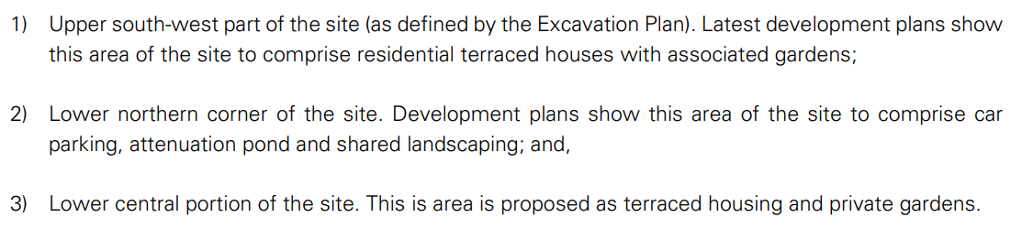
4.2 The report suggests that while roads and building may act as a pollutant “barrier” but a long-term risk to groundwater and from soil vapours would still exist if the (soil) source material is not removed from the site. Gardens and soft landscaping where a much higher risk. The report identifies 3 types of user in these area, groundworkers on site for the development are at a lower risk because they are there short term. Residential users accessing soft landscaping on those areas and Residential users using their gardens were at the most risk. Ridge and Partners consider this risk unacceptable and say remedial work is required. (See Appendix 1)

The report identifies that Radon protection measures will need to be incorporated into every building involving enclosed structures – typically a specified membrane and vented sub-floor.

4.3 The report suggests 3 options for mitigation

1) Leave majority of contaminated soil on site:
Contaminated soils and perched water in the northern corner of the site removed to reduce unacceptable risk to controlled waters (groundwater and river). 110m3 of Stable Non-Reactive Hazardous Waste around TPJ and TP12 at circa 0.20-1.20mbgl, and 350m3of Non-Hazardous Waste at circa 0.50-1.50mbgl.
Cover system incorporated into areas of soft landscaping - 600mm of imported clean certified subsoil and topsoil in private gardens. 400mm in areas of shared soft landscaping. Geotextile membrane required beneath cover system in all areas.
Install hydrocarbon soil vapour membrane beneath all buildings.

Costs: £162/m3 for Non-Hazardous x 350m3 = £56,700
£350/m3 for Hazardous x 110m3 = £38,500
Clean certified soil would need to be imported to site at approximately £22/tonne.
Import volumes will be significantly increased if a cover system is required.

2) Remove all contaminated material from site.

Remove all contaminated soils from site as per classification in Section 7.3.
Validate material left in situ is clean and suitable through sampling and laboratory analysis.
Surplus arisings created from new drainage network, foundations etc used to fill excavation void. Arisings or crushed aggregate rolled to refusal should be used for backfilling, to avoid the creation of soft areas and limit the potential for ongoing settlement.
Cover system not required if clean soils from site can be used in areas of soft-landscaping and gardens.

Costs: £162/m3 for Non-Hazardous x 4000m3 = £648,000
£350/m3 for Hazardous x 210m3 = £73,500
Clean certified soil would need to be imported to site at approximately £22/tonne. Import volumes are likely to be less if a cover system is not required.

3) Bio-Remediate majority of contaminated soil on site.

Contaminated soils and perched water in the northern corner of the site removed to reduce unacceptable risk to controlled waters (groundwater and river). 110m3 of Stable Non-Reactive Hazardous Waste around TPJ and TP12 at circa 0.20-1.20mbgl, and 350m3 of Non-Hazardous Waste at circa 0.50-1.50mbgl. Budget costs as per Option 1.
Bio-remediate soils on site. Time to complete this would need to be built into the project timeline. Portion of site would need be reserved for remediation area.
Not guaranteed that bioremediation will remediate all soils given the high-end hydrocarbons identified, but cover system not required if clean soils from site can be used in areas of soft landscaping and gardens.
Additional investigation and testing likely required to validate remediation of soils and reduced soil vapour risk.

Costs: Clean certified soil would need to be imported to site at approximately £22/tonne.
Import volumes are likely to be less if a cover system is not required
Option 1 costs
£162/m3 for Non-Hazardous x 350m3 = £56,700
£350/m3 for Hazardous x 110m3 = £38,500

Conclusions

1. Tisbury and West Tisbury Neighbourhood plan support the development of any further residential homes on Brownfield sites and believes there are sufficient sites to meet future housing need.
2. Tisplan is committed to minimising any pollution and where contamination may have a biological effect on residents, it can be considered pollution.
3. Tisplan also highlights the risk that any development might have from on-site contamination affecting the River Avon SAC.
4. Tisplan also highlights the potential for new residential development to increase phosphate levels in the River Nadder. Taking account of sources, the density of population in any development will increase that risk.
5. The station works development needs to be “Phosphate neutral”. Current Building regulations may not be sufficient for this and additional mitigation measures may be needed funded through CIL payments/further measures provided by the developers. Outcomes are likely to depend on population density.
6. The neighbourhood plan requires the council to take into the account the potential impact of contamination and pollution on the environ and biodiversity.
7. While Station works has been allocated in Tisbury and West Tisbury Neighbourhood Plan as a Brownfield site, it does not appear on Wiltshire County Councils register of Brownfield sites suitable, available and achievable for residential development.
8. While the Neighbourhood Plan identifies the site has areas that are “seriously contaminated” the site is not listed on Wiltshire County Councils public register of contaminated Land.
9. The Neighbourhood plan is assessed as having a beneficial approach to Land, soil and water assessed against WFD and NPPF, requirements from both cover pollution and contamination.
10. The environmental risk assessment found that the soil was contaminated in three areas of the site, South West, Northern and lower central.
11. The South West and lower central area all contain housing in the proposed plans.
12. There are risks to site users in the three areas identified with the highest risk to those in housing with a garden but some risk also to residents using soft landscaping and groundworkers on site during development.
13. Ridge and Partners agree that the level of risk was unacceptable and required mitigation.
14. Common to all options is to remove contaminated soils and perched water in the northern corner of the site to reduce unacceptable risk to controlled waters (groundwater and river). 110m3 of Stable Non-Reactive Hazardous Waste around TPJ and TP12 at circa 0.20-1.20mbgl, and 350m3of Non-Hazardous Waste at circa 0.50-1.50mbgl. This is estimated to cost in the region of £95,200.
15. Ridge and Partners recommend option 3 as the most cost-effective option for the developers but comment that it will extend the project time line, do not guarantee that bioremediation will remediate all soils given the high-end hydrocarbons identified and say that further testing will be required to validate remediation of soils and reduced soil vapour risk.
16. Standard protection against the effects of radon gas will need to be used; a specified membrane and vented sub-floor.

Recommendations

Station Works is listed on the WCC register of Brownfield sites
Station Works is reported to WCC public register of contaminated land
Request information from the developers on how they intend to mitigate against increased Phosphate levels.
Request a change in design to move housing with gardens/sites with soft landscaping away from contaminated areas and that those areas are used for alternative purposes.
An objection to any application for planning is upheld until TCH clarify which option they are going to proceed with (with detail and timelines provided) and the Parish Council decide whether they feel that the option is acceptable, under the requirements of the Neighbourhood plan and given the risk assessment.

APPENDIX 1 Pollutant Linkage Assessment

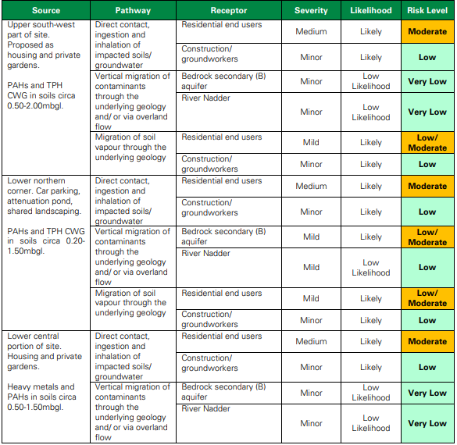

References

Tisplan Section 1.3 Section summaries p6
National Library of Medicine Determining when contamination is pollution - weight of evidence determinations for sediments and effluents https://pubmed.ncbi.nlm.nih.gov/17027966/ 15.08.21
Special Area of Conservation
Tisplan Section 2 HNA 63 P19
Phosphorus and Freshwater Eutrophication Pressure Narrative Environment Agency Published October 2019
Community Infrastructure Levy
Tisbury Neighbourhood Plan Section 3 Housing and Building p33
Part 1 is for sites categorised as previously developed (brownfield) land which are assessed as 'suitable', 'available' and 'achievable' for residential development. https://www.wiltshire.gov.uk/planning-brownfield-register
See separate report on Biodiversity
See separate report on the impact of development on River Nadder
https://www.wiltshire.gov.uk/env-health-contaminated-land
Strategic environmental assessment
The Water Framework Directive (WFD) originates from the EU but has been retained in UK law following the UK's exit from Europe. At its core it aims to prevent deterioration of the water environment and improve water quality by managing water in natural river basin districts, rather than by administrative boundaries
polycyclic aromatic hydrocarbons
Total Petroleum Hydrocarbon
Tisbury and West Tisbury Neighbourhood Plan Tisbury and West Tisbury Neighbourhood Plan Steering Group made November 2019 Strategic Environmental Assessment for the Tisbury and West Tisbury Neighbourhood Plan AECOM Infrastructure and environment UK Ltd January 2019 Environmental Risk Assessment for Tisbury Ridge and Partners November 2020 Julie Phillips 15th August 2021 Gerry – Size and Scale Tisbury Parish Council supports the development of the Station Works site as described in TisPlan, Tisbury’s made neighbourhood plan. However, the Parish Council objects to the current development proposal by Tisbury Community Homes at Station works on the following basis. - Size and scale of the development including: - Inappropriate dwelling density compared with existing settlement area in an AONB - Impact on local infrastructure particularly the effect of a large care home on medical services - Environmental impact on Nadder River of such a large scheme Housing Density and Number of Dwellings Introduction Given the position and shape of the site there are several in built constraints. It is long and thin bounded on one side by a railway line and on the other by a steep and inaccessible slope. (see photo gallery) These constraints dictate that judgements as to size and scale of the development should tend to the lower end of what is possible. In addition the close proximity to the Nadder river requires a conservative approach to the scale of the development. The developer Tisbury Community Homes and their agent Intelligent Land have taken the opposite view producing a proposal which will result in an overcrowded development offering a poor quality of life, clear environmental and medical risk and certainly a size and scale inappropriate for a village in an AONB. There has been no consideration given to the creation of a beautiful place nor any vision of a high quality 21st century village life. They have rejected the Tisbury Community’s vision as laid out clearly in Tisplan Based on the figures provided by Intelligent Land to the public meeting on 27th May, development of the site as proposed can be expected to increase Tisbury’s population by 12.3% compared with 2011 census levels. Against this background public concerns expressed regarding the acute pressure on health provision and on the traffic/parking appear to be fully justified. It would mean that 10.9% of Tisbury’s population housed on the development would be boxed into land comprising less than 3% of Tisbury’s total built-up area. On any measure the housing density proposed for the Station Works site is unnecessary, far too high and bears no relation to its surroundings, being over twice that of Tisbury’s most recently built estate (the Wyndham Estate) and over 1.5 times Wiltshire Council’s indicative figure for an estate of its size. The housing density proposed is over four times that of Tisbury village’s built environment, defined as the area within Tisbury’s revised settlement boundary (excluding the railway station and Station Works site). This has the following, highly damaging effects: - It actively frustrates place-shaping by creating a distinct ‘ghetto’ whose form and density contrasts to a remarkable extent with those already in the village. - It fails to secure sustainability, by creating homes which will be substantially inferior in amenity, outlook, space and privacy to those elsewhere in the village. In Wiltshire’s emerging local plan Tisbury’s housing allocation to 2036 is 65 homes. (see appendix D) We already have 13 being developed at the Old Sport’s Centre by Stone Circle and supported by the community leaving a requirement of 55. We have a further 10 dwelling development within the settlement area currently seeking planning permission which is likely to be granted. There is no evidence that this proposed level of development at Station Works is required or justified. Housing Density detail With a total population of 2,253 (2011 Census) the current population density within Tisbury’s built environment is 33 persons per hectare. Tisbury’s built environment is defined as the area bounded by Tisbury’s settlement boundary, excluding the railway station and the Station Works site, which are not currently habitable. Tisbury’s settlement boundary includes roads, private gardens, brownfield and small, integrated public spaces, but excludes playing fields, countryside and parkland which surround the settlement, all of which fall outside the settlement boundary. A map and supporting information are provided at Appendix [A]. The developer proposes construction of 86 new homes and a large, 70 person residential home over a built environment which occupies an area of 2.02 hectares and is substantially smaller than the area of land owned by the developer. This is because the developer’s land also includes a strip adjacent to the railway tracks (reserved for railway expansion) and steeply sloping woods and countryside surrounding the built estate (which borders but is not part of the developable site). This slope is also outside the settlement boundary. A map of the proposed site and supporting information is provided at Appendix [B]. Based on Intelligent Land’s own assumption of 2.4 occupants per dwelling (as stated to the public meeting on 27th May 2021) this leads to a housing density of 136 persons per hectare on the developed site (2.02 hectares). Assuming the 70 residents of the home were housed in dwellings of 2.4 persons per dwelling, this equates to a total of 115 dwellings on the Station Works site, giving a total of 57 dwellings per hectare. This compares with a total of 26 dwellings per hectare on the recently built Wyndham Estate in Tisbury, which contains 90 dwellings over a total area of 3.44 hectares. It compares with an indicative figure of between 30 dwellings per hectare and 35 dwellings per hectare stated in Wiltshire Council’s Strategic Housing and Land Availability Assessment 2011 and Strategic Housing and Economic Land Availability Assessment 2017. The upper figure of 35 dwellings per hectare was calculated by Wiltshire Council using the evidence of site completions of similar size between 2009 and 2014 in South Wiltshire and was based on a thorough viability assessment. Further details are provided at Appendix [D] below. The total of 115 dwellings planned by the developer significantly exceeds the indicative figure of 60 dwellings for the site, plus commercial area set by the Tisbury Neighbourhood Plan, made in 2019. The Neighbourhood Plan corrected an error made in the site assessment by Wiltshire Council in 2011, which had applied a density of 30 dwellings per hectare to the entire land area owned by the developer (4.12 hectares) rather than the area of the developed site (2.02 hectares). The area owned by the developer outside the developed area is in fact also outside Tisbury’s settlement boundary. It is a rising slope of some 35/40 degrees which leads on to private agricultural land and provides no amenity whatsoever. It cannot possibly be considered in any calculation of housing density and is in fact a hazard that will have to be dealt with in the development process. The slope has been found to be unstable and has required a retaining wall to be installed.(see photo 4) According to the Structural Soils Ltd – Site Investigation Report (1995) an investigation uncovered a failure at the cutting/embankment as follows: The failure at the cutting was said to have occurred primarily due to the weathering of a lower weaker unit (Rock) below a more competent unit on an overly steep slope. Suggested remedial measures were to address the problem of weathering of the weaker material and add to its stability. This was to be achieved by using a gabion or crib wall at the lower portion of the cutting/embankment, with the upper portion cut back to a stable angle in the order of 35°. Further details are provided at Appendix [B] below. Population density The scale of the problem is made clear by calculating the extent to which Tisbury’s population will increase following development. Based on Intelligent Land’s own assumption of 2.4 persons per dwelling and including the proposed 70-bed residential home, the resident population of the site will be 276. The population of Tisbury (2011 Census) was 2,253, meaning that development of the site will increase Tisbury’s population by 12.3%. Tisbury’s built area comprises 71.4 hectares and the developed Station Works site represents 2.02 hectares (2.82% of the current Tisbury village). With the development included, this means that 10.9% of Tisbury’s population will be boxed into land representing under 3% of Tisbury’s built area. It therefore seems clear that on any measure, the housing density proposed for the Station Works site is far too high and grossly out of proportion to other parts of Tisbury, being twice that of Tisbury’s most recently built estate (the Wyndham estate), over 1.5 times Wiltshire Council’s indicative figure, over 1.5 times the figure allocated in the Neighbourhood Plan and over four times higher than that of Tisbury village as a whole. The care home A 70 person care home is clearly a dramatic addition to the Tisbury population with all the consequential effects on the environment and the Nadder river in particular. As pointed out elsewhere the local medical infrastructure could not cope with such a care home. Perhaps the best argument against a care home on this site is put by the developers themselves. In a submission to a consultation on the Tisbury neighbourhood plan in 2019 Intelligent Land at that time stated the following: Wiltshire Core Strategy Policy 46 addresses the needs of Wiltshire’s vulnerable and older people. It states that such accommodation should be provided in sustainable locations, where there is an identified need, within settlements identified in Core Policy 1 (normally in the Principal Settlements and Market Towns) where there is good access to services and facilities. Tisbury is not a principal settlement nor market town, but a local service centre. Policy 46 deals with such circumstances by stating, “In exceptional circumstances, the provision of specialist accommodation outside but adjacent to the Principal Settlements and Market Towns will be considered, provided that: - a genuine, and evidenced, need is justified - environmental and landscape considerations will not be compromised - facilities and services are accessible from the site - its scale and type is appropriate to the nature of the settlement and will respect the character and setting of that settlement.” It is contended that due to the lack of evidence in the neighbourhood plan to substantiate this part of the policy as well as the isolation and separate location of Station Works and its poor proximity to Tisbury’s facilities and services, that this site is not appropriate for elderly care. Further, Dudsbury Homes Southern has received correspondence from three specialist leading developers of older person housing (Churchill, Renaissance and McCarthy Stone) which states that the Station Works site is not considered suitable given its proximity to the rail station and its isolation from the services and facilities of Tisbury. If a provider for this specialist use could not be found, this would present a further barrier to delivering development, in addition to those set out below Tisbury Parish council agreed with this analysis by Intelligent Land at the time and still does. Importantly it states the need for evidenced development which they have made no attempt to produce for either the care home or indeed any other part. Policy Framework with respect to housing density The proposed housing density and scale is materially in contravention of Tisbury Neighbourhood Plan Policy BL7 (4) which states “the estimated capacity of the site is 60 dwellings in two storey buildings plus commercial uses, but density overall must be appropriate for the edge of a rural settlement in an AONB with the potential to impact on the Conservation Area and two Special Areas of Conservation (SAC) (the River Avon SAC and the Chilmark Quarries SAC).” The proposed density of 57 dwellings per hectare substantially exceeds the range of 30-35 dwellings per hectare indicated for a site of 2.02 hectares as set out in Wiltshire Council’s Strategic Housing Land Availability Assessment (2011) and its Strategic Housing Economic Land Availability Assessment (2017). It overlooks Wiltshire Core Policy 57, which states that development must respond “positively to the existing townscape and landscape features in terms of building layouts, built form, height, mass, scale, building line, plot size, elevational design, materials, streetscape and rooflines to effectively integrate the building into its setting.” Paragraph 5.146 of the Wiltshire Core Strategy states that “the Core Strategy will seek to ensure that modest new growth in Tisbury will be sympathetically designed and located so it blends with the village and takes account of the constraints presented by narrow access roads and the sensitive landscape of the AONB.” The failure to set a density which takes account of local transport impacts, the well-being of the occupants and the character of the local area conflicts with NPPF Policy 122, which states that decisions should take into account “the availability and capacity of infrastructure and services - both existing and proposed - as well as their potential for further improvement and the scope to promote sustainable travel modes that limit future car use”, “the desirability of maintaining an area's prevailing character and setting (including residential gardens), or of promoting regeneration and change”; and “the importance of securing well-designed, attractive and healthy places.” Effect on local infrastructure including medical services (to be added by surgery practice manager) Environmental Effect on Nadder River A Strategic Environmental Assessment was completed by AECOM for the Tisbury Neighbourhood plan at the time of submission in January 2019. This report was concerned with the environmental impact of development including Station Works. The following extracts are relevant : Page 21 : ‘In terms of the key allocation proposed through the Neighbourhood Plan at Station Works, the site is within an Impact Risk Zone for the River Avon SSSI relating to residential developments of over 100 dwellings’. P12 refers to the need to ‘provide for modest growth’ with the need for employment and housing to be balanced. Being in an AONB ‘a modest and sustainable level of development’ is required. There is also consistent reference to the need for any proposed development or plan to state how they will take active steps to enhance the water quality, as well as protecting species, environments and habitats that support biodiversity. There does not appear at this stage to be any suggested action that would support the continued improvement of the Nadder River such as: P11: • Ensure that no development takes place in areas at higher risk of flooding, taking into the likely effects of climate change into account? • Improve green infrastructure networks in the plan area to support adaptation to the potential effects of climate change? • Sustainably manage water run-off, ensuring that the risk of flooding is not increased (either within the plan area or downstream) and where possible reduce flood risk? • Ensure the potential risks associated with climate change are considered through new development in the plan area? • Increase the resilience of biodiversity in the plan area to the effects of climate change? Any consideration on the impact of the Station Works development would have to take into account immediate effects on the river, not only in Tisbury but further downstream, as well as any potential impact on the water meadow within Tisbury. P30: The citation for the SSSI states: ‘The River Avon and its tributaries are of national and international importance for their wildlife communities. The Wiltshire tributaries, of interest in their own right and with contrasting geologies, are included primarily on account of their importance, with the Avon itself, for internationally rare or threatened species (Ranunculus vegetation, sea lamprey, brook lamprey, bullhead, Atlantic salmon and Desmoulin’s whorl snail) It is clear this development carries significant environmental risk particularly to the Nadder River due to the developers wish to maximise financial return from a very high density design without any mitigation measures. -------------------------------------------------------------------------------------------------------------------------------------------------------------------------------------------------------------------------- APPENDIX A - TISBURY BUILT ENVIRONMENT ➢ The map below highlights the built environment of Tisbury, as defined in the Tisbury Neighbourhood Plan 2019, meaning the built area within the Tisbury Settlement Boundary (the Settlement Boundary excludes surrounding recreation grounds, parks, paddocks, woodland and rivers). ➢ Tisbury’s built environment comprises: • Tisbury Village • Tuckingmill ➢ The highlighted area does not include the Station Works site, which is uninhabited and physically separated from the inhabited village of Tisbury by the South Western Railway. ➢ The total area of Tisbury’s built environment as highlighted below is 0.6747 Km2 or 67.4 hectares, comprising: • Tisbury Village 0.637Km2 (63.7 hectares) • Tuckingmill 0.0377Km2 (3.77 hectares) ➢ Tisbury’s population (2011 Census) is 2,253, giving a density of 33.4 persons per hectare.. Tisbury Built Environment (mapping courtesy Google llc For comparative purposes, Tisbury’s settlement boundaries are shown below (Source - Wiltshire Council, Housing Site Allocations Plan, Community Area Topic Paper – Tisbury, July 2018). Station Works APPENDIX B – STATION WORKS BUILT ENVIRONMENT ➢ The map below highlights the total area of the land owned by Tisbury Community Homes Ltd. (marked in light blue) together with the area of the proposed development (marked in light red), which excludes steeply sloping woodland and surrounding countryside and the land reserved for expansion of the railway line by Network Rail. • The total area of the land owned by the developer is 4.12 hectares (including surrounding countryside and the land allocated for railway expansion) • The built environment of the Station Works development is 2.02 hectares. This is the area of the proposed estate. ➢ As for Tisbury Village (see Appendix [A] above) the Built Environment includes roads, buildings, private gardens and integral public spaces, but excludes surrounding countryside and land belonging to Network Rail. Station Works Built Environment (mapping courtesy Google llc) APPENDIX C – WYNDHAM ESTATE BUILT ENVIRONMENT ➢ The map below highlights the total housing area of the Wyndham Estate, built by C. G. Fry between 2010 and 2014 under Planning Consent S2008/0779. The housing area (marked in beige) excludes surrounding countryside, woodland and the commercial area of the estate. • The total housing area of the Wyndham Estate is 3.44 hectares • The estate supports 90 dwellings comprising 34 affordable homes, almost all of 2-bedrooms and 56 dwellings of with an average of 3.5 bedrooms. • This gives a density of 26 dwellings per hectare. Wyndham Estate Built Environment (mapping courtesy Google llc) APPENDIX D – INDICATIVE HOUSING DENSITY ➢ The table below appears in Wiltshire Council’s Strategic Housing and Economic Land Availability Assessment 2017 and is based on completed developments in South Wiltshire between 2009 and 2014. Larger sites are shown to be associated with lower housing densities, to enable the necessary space for public amenity and recreation. APPENDIX E – 15-YEAR HOUSING REQUIREMENT FOR TISBURY ➢ The table below appears in Wiltshire Council’s emerging Local Plan (Empowering Rural Communities section) and shows the housing requirement set for Tisbury 2016 to 2036. ➢ Of the total housing requirement of 135, 70 units were completed between 2016 to 2019 or are already committed, leaving a requirement of 65 units within the Tisbury settlement boundary between 2021 and 2036, an average of 4.3 units per year. APPENDIX F – OFFICERS’ REPORT ON APPLICATION S2003/2547 ➢ The following extract is taken from the Officers’ Report with recommendations for refusal of a previous, similar application by St. Modwen Developments Ltd. for residential development of the Station Works site. RECOMMENDATION: REFUSE for the following reasons: (1) This proposal is contrary to policy E16 of the adopted Salisbury District Local Plan in that the proposal would result in the loss of a large employment site, does not result in demonstrable environmental or conservation benefits nor does it provide for a similar number and range of job opportunities. Insufficient evidence has been supplied to demonstrate that the site is not viable in its entirety for employment uses. Furthermore, this is a large site and the loss of available land for employment/industrial use is of significant importance. (2) The proposed development is considered by the Local Planning Authority to be contrary to Housing Policy H22 of the adopted Salisbury District Local Plan in that the relocation of the existing business is likely to lead to increased reliance on the private car and insufficient evidence has been supplied to demonstrate that the site is not viable for alternative employment uses. (3) The proposal, which involves the loss of employment land in a settlement where there has been a loss of such land over the years, is contrary to policy G1 of the adopted Salisbury District Local Plan and DP1 of the Wiltshire Structure Plan in that it does not help create sustainable communities (4) The proposal is considered to be contrary to policy DP1 of the approved Wiltshire Structure Plan and the aims of PPG13 in that The proposed development has not demonstrated that adequate provision can be made to accommodate the requirements of disabled people crossing the proposed new footbridge over the railway. This will lead to wheelchair users wishing to access the railway station and the main part of Tisbury village (and vice versa) having to travel via a circuitous route along a section of Class lll road where there are no footways and where visibility is restricted to the detriment of highway safety. (5) The proposal is considered to be contrary to policy G1 of the adopted SDLP, DP1 of the approved Wiltshire Structure Plan and the aims of PPG13 in that it is likely to lead to an increase in out commuting car borne traffic on a local road network that is ill suited to increased levels of demand (6) The proposal is contrary to policy G1 of the adopted Salisbury District Local Plan in that it contains insufficient information to demonstrate that the site could be satisfactorily drained without an increased risk of flooding off site. (7) The proposal is considered to be contrary to policy R2 & R4 of the adopted Salisbury District Local Plan in that it makes no provision for recreational open space or community facilities. Photo Gallery Photo 1: Aspect from North East Photo 2: Railway line from North East Photo 3:Viewf rom furthest point NorthEast Photo 4: Slope with retaining wall Photo 5: slope indicates edge of settlement area Nick – Planning Advice from Wiltshire Council A summary of Planning Officer advice received so far: Masterplan Richard Hughes: - A Masterplan is not easily defined and the Design and Access statement could constitute one - Complete agreement often not reached on Masterplans – competing interests considered in planning application process - PC do not have to support masterplan and lack of support from PC significant material consideration in determining application, given allocated site in NP - Draft Masterplan: NP policy BL7 requires a masterplan. It can be ‘draft’ for purposes of public consultation but all documents submitted with application should be finalised versions, not draft. However, a document marked ‘draft’ is not grounds for refusal in itself Size of site and density (questions from Gerry / you) - Council interpret size entirely based on area of red line on application. Can be larger or smaller than allocated site in NP - Density – refusal not normally based solely on the numbers but layout look and feel (cramped, congested, overdeveloped) Highways Chris Manns: - ‘in principle’ agreement to closure of arch for pedestrian access as something that is needed - Requirement though for traffic modelling data from developer before decision made, not received to date Clerk – Comments from Previous Applications for the Station Works Site; approved and refused Previous applications for the site now available on the Wiltshire Council website are not necessarily complete (in terms of documents available) and not necessarily in the same format. Only applications since the year 2000 were considered and from then until the present day the regulatory /policy documents in force at the time of determination have undergone significant revision. In addition, the structure of local government has also changed along with the associated local policies in place. The comments below are therefore not related to specific applications, but do relate in part at least to TisPlan, the Made Neighbourhood Plan: Employment - The loss of varied employment opportunities and the number of employees on the site does not result in demonstrable environmental and/or conservation benefits. Housing - The total number of dwellings, type of dwelling and affordability should relate to a recently conducted Housing Needs Survey. - Low cost market dwellings to be covenanted for the future. - Affordable housing to be held in perpetuity as such. - The site should be easily accessible for pedestrians, including those with disabilities in wheelchairs for example, and also young families with prams and children on scooters – improvements in accessibility as a cost to the developer. Safety - Suitable access points from the site to the main village community are required to ensure physical and mental health benefits; inadequate pedestrian links in particular will lead to an increase in use of the pedestrian level crossing (a current footpath). - The lack of adequate or non-existent pavements along the C-road leading into the village. Drainage / Flooding - On-site drainage plans must take account of the potential effect off-site, especially at the 3-Arch Bridge and the Stubbles footpath. - Water and foul sewerage systems are available on site, but not surface water (unless recently installed); adequate surface water disposal must be developed to ensure no exacerbation of the current high flood risk at Stubbles, 3 Arch Bridge and Lower Recreation Ground in particular Recreational Facilities - Provision of green space (and/or investment into current play facilities) should form a part of the application for the site. Environmental Considerations - Any demolition works should control noise and dust; ongoing work should be restricted by specified hours of work. - Network Rail / Great British Rail to be notified of all works in advance. - Details of land contamination and remediation to be specified in advance. Area of Outstanding Natural Beauty - Proposed plans should take account of the high visibility of the site from many points across Tisbury – but not so from the entry roads into the village. Travel, Traffic and Transport - A Travel Plan to show how residents, commuters and visitors would travel to the site other than by car. - The Travel Plan to indicate targets for different modes of transport use, e.g. cycling, walking, train, car and car sharing. - A programme of monitoring and review for the Travel Plan to assess whether targets are met and how to address if they are not. Clerk – Initial Thoughts from Richard Burden (May 2021) I took a very swift look at the proposals on 12th May and it seemed to be very unimaginative, not addressing the issues of parking for the station, spreading development in a not particularly efficient way, and apparently [from the visuals] putting higher blocks north of smaller buildings tucked under the southern slope [and hence restricting views / diminishing quality and sense of place]. The spine road seems to duplicate the railway, and not make good use of space, as well as no ‘thinking outside the box’ to solve the issues of the narrow / low railway bridge at the western side. Why not a new access at the eastern end? The scheme seems to be the developers’ preferred approach rather than testing the water to see whether the community is interested in more innovative ideas, such as development at the southern side with green roofs / frontages and some innovative ways of handling much more parking [if the railway is to be the future sustainable transport]. One simple question, how do people living on the south side of the railway get to the shops etc; are there bridges / underpass?? Questions and Answers from JWG to Richard Hughes - Team Leader South Hub, Economic Development and Planning - We have been told we cannot see the pre-app advice. We presume we will see it in full when a planning application is made. Is this correct? No, PREAPPs are kept confidential, although it is sometimes the case that the applicant chooses to submit a copy of the preapp advice from the Council with the application, and hence, in that instance, it would be available to the public. However, please be assured that we made clear to the developer what the issues were with the site and the scheme, and that we would expect any future scheme to have been discussed and agreed with the local community. Issues surrounding the access were also highlighted in detail to him. - The developers have not shared the results of their own local consultation with us. Have you seen it? No. Ive had no contact with the developer since issuing the preapplication advice. - Having been told in June that the owners of Station Works wished to proceed directly to a planning application we have heard nothing from the developer Intelligent Land for some time. Have you? No. Ive had no contact with the developer since issuing the preapplication advice. Please note that developers often suggest that an application is imminent, and then take several months to apply, so this is nothing unusual. We presume they are waiting until our Neighbourhood Plan is two years old and will apply then. This begs several questions: - Will less weight be given to our Neighbourhood Plan given Wiltshire’s 5-year land supply situation? Please try and quantify this and perhaps give an example from the plan where this would not be the case. The application will need to be considered against the policy situation at the time the application is submitted. Both national and local plan policies may have altered in a few years time, so its not really possible to answer this question with much clarity. The Council may of course have a 5 year land supply in future years. If it doesn’t, and your NP is over two years old, then yes, that will have some impact on our ability to refuse any application for housing. However, the 5 year housing land supply issue is only one of the many material considerations we need to take into consideration, and we would not have to approve any form of application just because we may not be able to demonstrate a 5 year housing supply – there may be access/design, or other issues for instance. - Does the recent judgement by Wiltshire’s SPC in the very recent Malmesbury case 19/05898/OUT (against the advice of the Planning Officer) change this? Is this now a precedent for Wiltshire planning? We understand the issue from the NPPF point of view, but we really need to understand the position of Wiltshire planning. Clearly this is crucial to our local community (and many others throughout Wiltshire). I don’t know the particular details of the application, but each application case is considered on its merits, and therefore just because the Council appears to have considered a particular application a certain way, does not mean it will treat other applications in other areas a similar way. The circumstances of each case and site are different. The Malmesbury refusal reason seems to indicate that the site was not allocated in a neighbourhood plan, so it does not appear to be similar to the station works site in that respect. - One of the last things we were told by Intelligent Land was that the scheme for Pedestrian Access had been approved “in principle”. Is this true? Has any traffic data been supplied by the developer? Who will provide evidence and judgement on how the risk of flood at Three Arch Bridge will impact the proposed pedestrian access scheme? The comments of WC Highways and WC Drainage will be sought on any future application, and so they will opine on this matter. My understanding is that the developer has had some discussions direct with WC Highways regards the access issues, and they raised a number of issues regards those matters as part of the preapplication response which the developers will need to take into account. Whether or not any highways/drainage works may be discuss or agreed with the Council as Highway or Drainage Authority does not mean that they will be automatically approved via the planning process. - If the CO-OP is successful in their planning application PL/2021/07526 to move to the new site adjacent to the bridge, will the effect this has on traffic around the bridge be taken into account? As WC Highways will be consultee on both these applications, their comments on any future tisbury station works site applications will be made in the knowledge of any approved scheme regards the CO-OP. - When our Neighbourhood Plan was completed based on a 60-dwelling development we believe an environmental impact report on the effect on the Nadder river was produced by Wiltshire Council. We have been unable to locate this document. Do you have a copy? Or do you know where we can find a copy? Im afraid I don’t have a copy of the document. Details of the Neighbourhood Plan contact are on the Council website, under the Neighbourhood Planning section should you wish to contact the team. Link below to the contact details: Neighbourhood planning - Contact us - Wiltshire Council - Will the recent (20th July) changes to the NPPF have a material effect on planning approval? We are thinking in particular of the need for a development to demonstrate biodiversity gain. The current version of the NPPF has added sections on design and landscaping, and so better supports general good design and masterplanning. Any future application will need to be considered against the requirements of the latest version of the NPPF, and also any other national and local policies at that time. Wiltshire’s own ecology policies already refer to the requirement for a biodiversity gain. However, please note that all relevant material consideration, of which ecology is only one, will need to be taken into consideration if and when an application is considered. - We were hoping you might be able to help us clarify another point about the impact of land supply on Wiltshire planning decisions. Note 8 of the July 2021 NPPF makes clear that for applications involving provision of housing, development plan policies which are most important for determining the application are “out of date” in situations where “the local planning authority cannot demonstrate a five year supply of deliverable housing sites (with the appropriate buffer, as set out in paragraph 74); or where the Housing Delivery Test indicates that the delivery of housing was substantially below (less than 75% of) the housing requirement over the previous three years.” I believe that Wiltshire at present doesn’t meet the test set out in Note 8. Paragraph 11(d) of the NPPF goes on to say where these development plan policies are “out of date” an LPA should grant an application unless, either: - the application of policies in this Framework that protect areas or assets of particular importance provides a clear reason for refusing the development proposed; or - any adverse impacts of doing so would significantly and demonstrably outweigh the benefits, when assessed against the policies in this Framework taken as a whole. Note 7 to the NPPF goes on to clarify this a little by saying that “The policies referred to are those in this Framework (rather than those in development plans) relating to: habitats sites (and those sites listed in paragraph 181) and/or designated as Sites of Special Scientific Interest; land designated as Green Belt, Local Green Space, an Area of Outstanding Natural Beauty, a National Park (or within the Broads Authority) or defined as Heritage Coast; irreplaceable habitats; designated heritage assets (and other heritage assets of archaeological interest referred to in footnote 68); and areas at risk of flooding or coastal change.” Tisbury is within an AONB which suggests that this means that planning decisions: - should assign limited or no weight to the existing Wiltshire Core Polcies - should assign great weight to the NPPF Policies on AONB However, in recent discussions, a lot of attention has been paid to the Wiltshire Core Policies, with the implication that applications must not conflict with them. It therefore looks as though the Wiltshire Core Policies do have full weight, but as that doesn’t seem to be consistent with NPPF paragraph 11(d) We think we must be missing something. Can you cast any clarity? In basic terms, the case law related to Para 11 indicates that its only the housing related policies (ie those that indicate how many homes are required etc) in the Development Plan that are out of date if the Council doesn’t have a 5 year land supply. The vast majority of the policies in the Development Plan therefore remain “in date” and relevant, including those in the Neighbourhood Plan. Furthermore, Para 11 does indeed stress that if the development is harmful to the AONB, then the 5 year supply issue does not apply.

